ST10528587

NKOSINOMUSA MASINGA
WEDE5020 POE
PART 3

Table of Contents
Website Choice
Website Goals and Objectives
Timeline and Milestones
Budget
Website Assets
Sitemap and Structure
Webpages and Content
Technical Requirements
Summary
References

Website Choice
Business Name: Musa Meat
Musa Meat is a local farming business that focuses on supplying fresh, high-quality beef products direct to customers. The business aims to provide affordable and reliable meat to households, restaurants, and small businesses within the community. Musa Meat ensures that all products are fresh and sourced locally, promoting healthy consumption and supporting local agriculture. In today’s digital age, many customers rely on the internet to search for products and services. Musa Meat currently operates without a strong online presence, which limits its ability to reach a wider audience. A website will allow the business showcase its products, provide pricing information, and improve communication with customers. The website will include key pages such as the homepage, about page, products page, enquiry page, and contact page. These pages will provide important information about the business and make it easier for customers to interact with Musa Meat. The target audience includes local households, restaurants, and small businesses that require fresh and affordable meat products. By creating a website, Musa Meat will be able to expand its reach and improve customer engageme
Reasons for Choosing This Business
Musa Meat was chosen because it represents a realistic small business that can benefit from an online presence. A website will improve communication, attract customers, and support business growth. Musa Meat represents a realistic small business that can benefit from having a Website. Many small businesses do not have an online platform, which limits their growth and visibility. One of the main reasons for selecting Musa Meat is that it allows the development of a practical and functional website that solves real-world problems. Customers often struggle to find information about products, prices, and contact details when a business does not have a website. Creating a website for Musa Meat will improve communication and make it easier for customers to access information. It will also help attract more customers and increase business growth. Additionally, this project allows the use of web development skills such as HTML, CSS, and JavaScript to create a user-friendly and responsive website.

Website Goals and Objectives
Increase awareness, showcase products, allow enquiries, improve communication.
KPIs: traffic, enquiries, engagement, sales

Timeline and Milestones
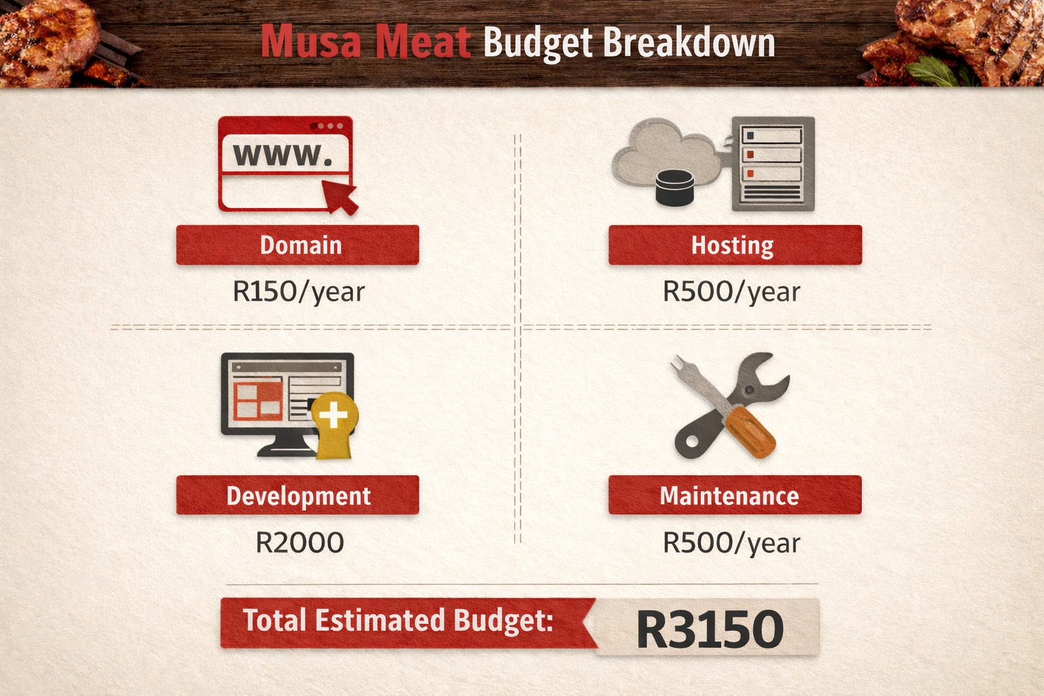
Week 1–4 development phases
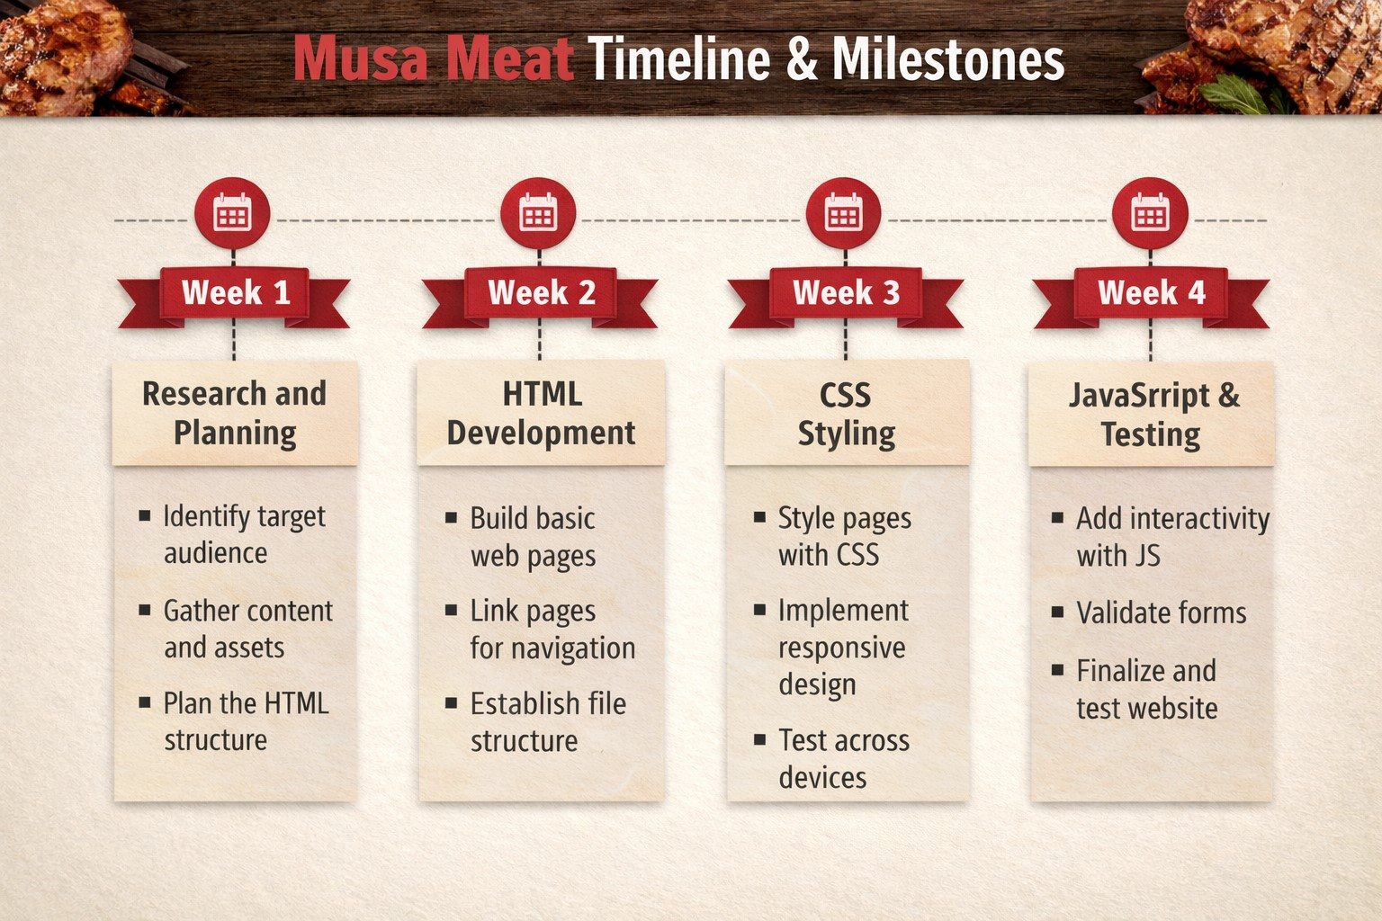
Budget
Domain, hosting, development, maintenance

Website Assets
Picture 1: Fresh beef products Source: Pexels (2026)
Picture 2: Cattle farm
Source: Unsplash (2026)
Picture 3: Butchery display Source: Pexels (2026)
Picture 4: Packaged meat Source: Unsplash (2026)
These images represent Musa Meat’s products and environment. They improve visual appeal and help users understand the business offerings.
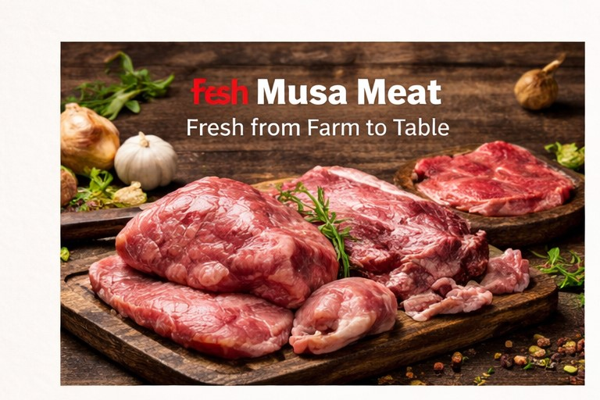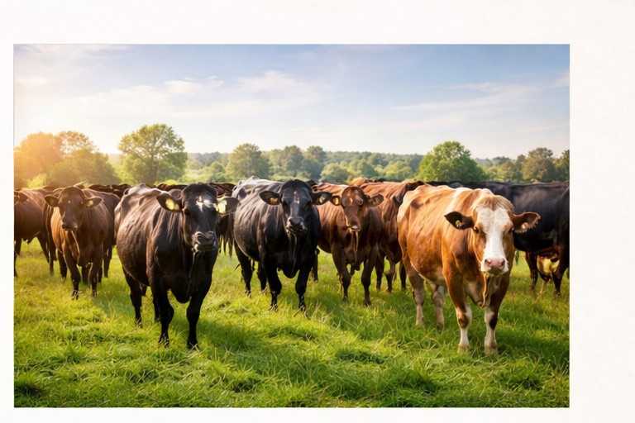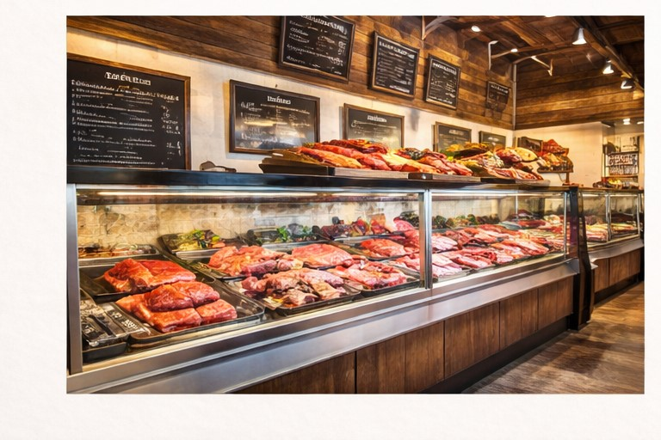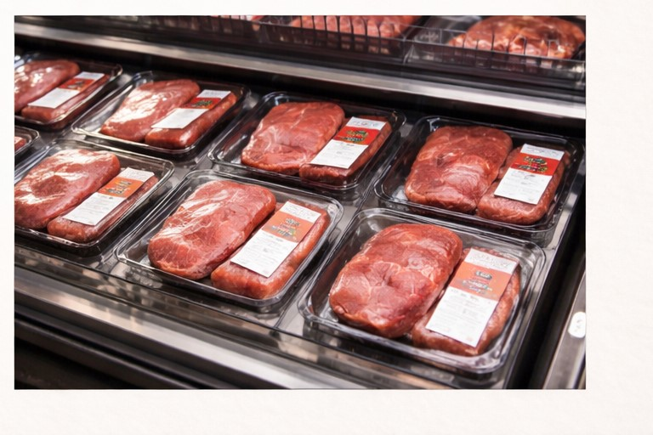

Sitemap and Structure
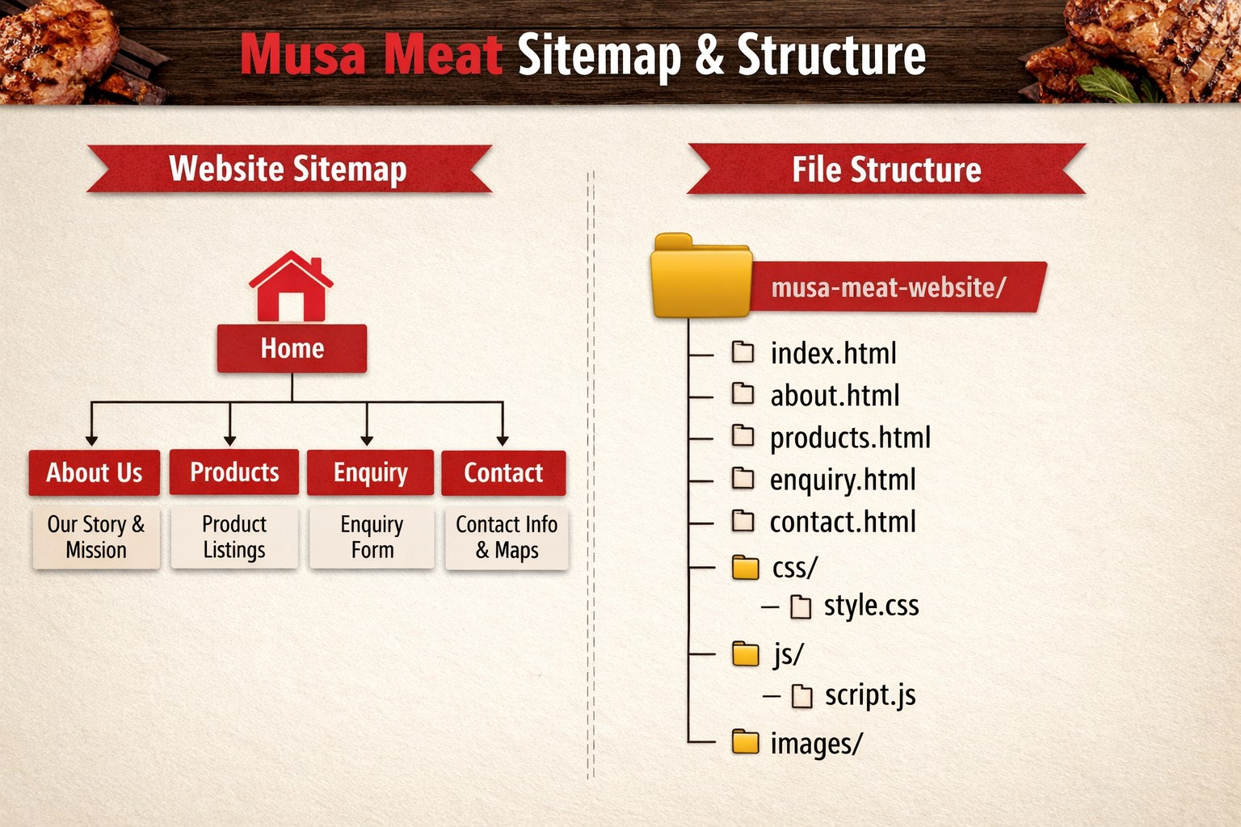

Webpages and Content

A. Home Page
The homepage uses a red, white, and black colour scheme. It includes a logo, slogan “Fresh from Farm to Table”, navigation links, a full-width farm image, product summary, contact information, and copyright. This page creates first impressions and improves user engagement.

B. About Page
The About page provides background information, mission and vision, a farm image, and contact details. It builds trust and explains the purpose of the business.
C. contact page
The Contact Page of the Musa Meat website is designed to provide users with a direct and convenient way to communicate with the business. It serves as an essential communication channel, allowing customers to make general enquiries, ask questions, or request support.
The page includes key contact details such as:
Business email address
Phone number
In addition, a contact form is provided to enhance user interaction. This form allows users to enter their:
Name
Email address
Message
The form uses HTML5 validation to ensure that all required fields are completed before submission. This improves data accuracy and enhances the user experience by preventing incomplete submissions.
From a design perspective, the page is kept simple and user-friendly, ensuring that visitors can quickly find contact information or send a message without confusion. The inclusion of this page improves customer engagement, accessibility, and professionalism, making it easier for clients to connect with Musa Meat
D. Enquiry Page
The Enquiry Page is specifically designed to handle customer requests related to products, pricing, and services offered by Musa Meat. Unlike the contact page, which is for general communication, the enquiry page focuses on business-related queries and potential orders.
The page features a structured enquiry form that collects important customer information, including:
Name
Email address
Enquiry type (e.g., Order, Pricing, General)
Message
The inclusion of an enquiry type dropdown menu allows users to clearly specify the purpose of their request. This helps the business organise and respond to enquiries more efficiently.
The form is built using HTML and includes required fields to ensure that users provide all necessary information. This improves the quality of enquiries and supports better communication between the business and customers.
Overall, the enquiry page plays a vital role in:
Generating leads
Supporting customer decision-making
Streamlining order-related communication
It contributes to the overall goal of the website by helping Musa Meat convert visitors into customers.

Hosting and Domain
The Musa Meat website will operate under the domain name www.musameat.co.za or www.musameat.com. The domain will be registered through a reputable South African registrar such as Domains.co.za or Afrihost.
To ensure reliability, security, and scalability, the website will be hosted on a Cloud VPS platform provided by Afrihost or Hetzner South Africa. An SSL certificate, such as Let's Encrypt or Comodo Positive SSL, will be installed to encrypt all website traffic and protect customer information.
Professional email accounts such as info@musameat.co.za and sales@musameat.co.za will be configured using Zoho Mail or Google Workspace. Cloudflare will be used as a Content Delivery Network (CDN) to improve website performance and security. Daily automated backups with a 30-day retention period will be implemented to ensure data recovery in case of system failure.

6.2 Technology Stack
The website will be developed using HTML5, CSS3, and JavaScript (ES6+) to ensure a modern and responsive user experience. Tailwind CSS will be used to provide consistent and efficient styling across the website.
React.js with Next.js will be used as the frontend framework to improve performance, search engine optimization, and scalability. WordPress with Elementor Pro will serve as the Content Management System (CMS), allowing administrators to manage website content easily.
WooCommerce will be integrated to support online product listings and order management. Payments will be processed securely through PayFast, allowing customers to pay using debit cards, credit cards, and EFT transactions.
The website database will be powered by MySQL with Redis caching to improve performance. GitHub will be used for version control and collaborative development. Website performance and visitor behavior will be monitored through Google Analytics 4, Google Search Console, and Hotjar. Accessibility standards will be maintained through WCAG 2.1 AA compliance and regular audits using Lighthouse and axe DevTools.

6.3 Security Requirements
The website will use HTTPS encryption to protect customer information and online transactions. Cloudflare Web Application Firewall (WAF) will be implemented to protect the system against cyber threats and malicious attacks.
Daily malware scanning and vulnerability assessments will be performed to identify and eliminate potential security risks. Administrator accounts will be secured through strong password policies and Two-Factor Authentication (2FA).
The website will comply with the Protection of Personal Information Act (POPIA) to ensure responsible handling of customer data. Payment transactions will be processed through PCI-DSS compliant payment gateways. Regular updates will be applied to the server, CMS, plugins, and security systems.

6.4 Performance Requirements
The website should load within three seconds on both desktop and mobile devices. A fully responsive design will ensure compatibility across smartphones, tablets, laptops, and desktop computers.
Images will be optimized using modern formats such as WebP and lazy-loading techniques to improve loading speeds. Redis caching and Cloudflare services will further enhance website performance.
The hosting environment will provide a minimum uptime guarantee of 99.9%. The system will be scalable to accommodate increased customer traffic, especially during promotional periods and business growth.

6.5 Search Engine Optimization (SEO) Requirements
The website will include technical SEO features such as XML sitemaps, robots.txt files, and schema markup. A Google Business Profile will be integrated to improve local search visibility.
Each page will contain optimized title tags, meta descriptions, and keyword-rich content. Structured data will be used to improve search engine understanding of business and product information.
Open Graph tags will be implemented to improve content sharing across social media platforms. SEO efforts will focus on keywords related to fresh meat sales, beef products, livestock farming, and meat supply services.

6.6 Integration Requirements
Google Maps integration will allow customers to locate the business easily and obtain directions. WhatsApp Business integration will enable customers to communicate directly with Musa Meat for enquiries and orders.
The website will integrate with Facebook and Instagram to support digital marketing and product promotion. Google Reviews will be displayed to build customer trust and credibility.
A newsletter platform such as Mailchimp will be used for customer engagement and promotional campaigns. Inventory management functionality will assist with product stock control and order tracking.

6.7 Maintenance and Support
The website will receive monthly updates to ensure optimal performance, security, and compatibility. Continuous monitoring will be conducted to detect downtime or technical issues.
Automated backup systems will support disaster recovery and ensure business continuity. Technical support will be available through email and telephone during business hours.
Training will be provided to Musa Meat staff to enable effective management of website content, customer enquiries, products, and online orders.

Summary page
The Musa Meat website is a professional online platform designed to showcase a local meat business that specialises in providing fresh, high-quality beef products. The website serves as a digital presence for the business, allowing customers to learn more about its offerings, values, and services.
The primary purpose of the website is to inform, attract, and engage customers while promoting Musa Meat as a reliable and affordable supplier of locally sourced meat. It highlights the business’s commitment to quality, freshness, and customer satisfaction.
The website consists of multiple interconnected pages, including a homepage, about page, products page, enquiry page, and contact page. Each page is structured to provide specific information
From a technical perspective, the website is built using HTML for structure, CSS for styling, and basic JavaScript for interactivity. It follows a clean layout with easy navigation, ensuring a user-friendly experience across different devices.
Overall, the Musa Meat website is designed to enhance the business’s online presence, improve customer communication, and support growth by making information and services easily accessible to users.

References
Google (2026) Google Maps. Available at: https://www.google.com/maps⁠� (Accessed: 20 April 2026).
Pexels (2026) Free stock photos. Available at: https://www.pexels.com⁠� (Accessed: 20 April 2026).
Unsplash (2026) Free images. Available at: https://unsplash.com⁠� (Accessed: 20 April 2026).
MDN Web Docs (2026) Web development resources. Available at: https://developer.mozilla.org⁠� (Accessed: 20 April 2026).
Website published on https://github.com/ST10528587/part-3

